**Project Overview**

**Project Name: -** **ROAM RAVE** (Feel free to change)

**Project Tagline: -** Follow where your heart follows (Feel free to change)

**Description: -** Travel vlog

**Project Structure: -**  
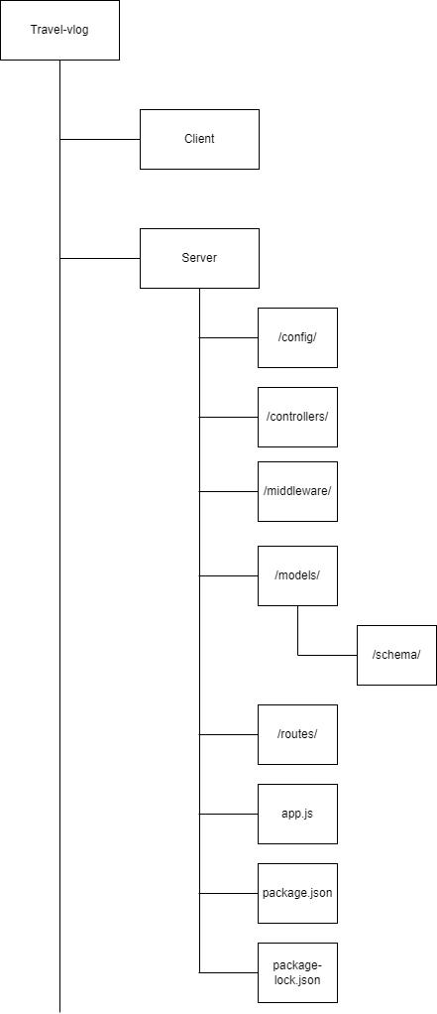

**Stakeholders: -**

* ADMIN
* USER

**Modules**: -

1. Register
2. Login
3. Captcha
4. Forget Password
5. Profile
6. User
7. Travel
8. Follow
9. Like
10. Comments
11. Share
12. Tokenization - Middleware

**Register: -**

* Sign Up – username, email, password, captcha
* Random generate 6-digit user Id for identification
* No token – No Middleware

**Login: -**

* Sign In – email, password, captcha
* Create token using user Id
* In response – username, email, token
* No token – No Middleware

**Captcha: -**

* Alphanumeric – 4 characters
* No token – No Middleware

**Forget Password: -**

* OTP to registered email
* No token – No Middleware

**Profile: -**

* Update the details
* Get the details
* Change the password
* With Token – use of middleware

**User: -**

* Add user
* Update the user details
* Get all user details
* With Token – use of middleware

**Travel: -**

* Add travel vlog details
* Update the travel vlog details
* Get travel vlog details
* With Token – use of middleware

**Follow: -**

* Add – (Follow)
* Delete – (Unfollow)
* Get Followers
* Get Following
* With Token – use of middleware

**Like: -**

* Add – (Like)
* Delete – (Unlike)
* Get likes
* With Token – use of middleware

**Comments: -**

* Add – (Comment)
* Get List – (Comment)
* With Token – use of middleware

**Share: -**

* Add – (Share to other people)
* With Token – use of middleware

**Tokenization: -**

* In middleware
* To verify the token
* To be used in routes while calling controller

**Work flow: -**

